Answer any three out of four questions.

1. a) Construct a truth table for the following compound propositions 5

(p imp.gif (64 bytes)q) eqv.gif (70 bytes) (not.gif (54 bytes) q imp.gif (64 bytes) not.gif (54 bytes) p)

b) No animals, except giraffes, are 15 feet or higher;   There are no animals in this zoo that belong to anyone but me;   I have no animals less than 15 feet high.  Therefore, all animals in this zoo are giraffes. Symbols to be used: Animals are giraffes (G). Animals are 15 feet or higher (F). Animals are in the zoo (Z). Animals belong to me (M).

Write propositional sentences for the above English sentences. Show the inferences rules to derive the conclusion “Therefore, all animals in this zoo are giraffes”. 10

1. a) For the following FOL knowledge base, prove ***Older(Lulu, Fifi)*** using resolution. 8

Mother(Lulu, Fifi)

Alive(Lulu)

∀x ∀y.Mother(x,y) ⇒ Parent(x,y)

∀x ∀y.(Parent(x,y) ∧ Alive(x)) ⇒ Older(x,y)

b) Translate the following sentences into FOL sentence 3+4

Mary loves everyone

Every student smiles

Every student except George smiles

Every student who loves Mary is happy

Every boy who loves Mary hates every other boy who Mary loves

1. a) Briefly discuss supervised learning vs unsupervised learning, over fitting problem in machine learning and different ways of pruning decision tree. 9

b) What is entropy? Why it is used to classify data in ID3 algorithm? 6

1. a) Suppose we want to classify potential bank customers as good creditors or bad creditors for loan applications. We have a training dataset describing past customers using the following attributes: Marital status {married, single, divorced}, Gender {male, female}, Age {[18..30], [30..50], [50..65], [65+]}, Income {[10K..25K], [25K..50K], [50K..65K], [65K..100K], [100K+]}.

***Draw neural network architecture for the above problem***. 5

b) Given the following neural network with initialized weights as in the picture, explain the network architecture knowing that we are trying to distinguish between nails and screws and an example of training tupples is as follows: T1{0.6, 0.1, nail}, T2{0.2, 0.3, screw}. 10

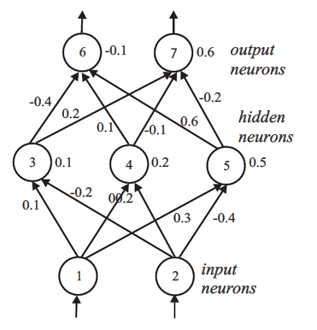

Let the learning rate ŋ be 0.1 and the weights be as indicated in the figure above. Do the forward propagation of the signals in the network using T1 as input, then perform the back propagation of the error. Show the changes of the weights.

Hint: Encoding of the outputs may be 10 for class “nail”, 01 for class “screw”